Bài 2:

Take an example of login page of an application which locks the user name after three wrong attempts of password.

Transition diagram

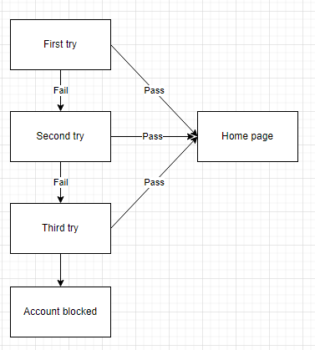

|  |  |  |  |
| --- | --- | --- | --- |
| State | Switch | Correct password | Incorrect password |
| S1 | First try | S5 | S2 |
| S2 | Second try | S5 | S3 |
| S3 | Third try | S5 | S4 |
| S4 | Account blocked |  |  |
| S5 | Home page |  |  |

Test case

|  |  |  |  |
| --- | --- | --- | --- |
| ID | Pre-condition | Steps | Expected result |
| 1 | At login page | 1st entering correct password | Turn to home page |
| 2 | At login page | 1st entering incorrect password | Error message:"The password you entered is incorrect. Please try again." |
| 3 | 1st entering incorrect password | 2nd entering incorrect password | Error message:"The password you entered is incorrect. Please try again." |
| 4 | 2nd entering incorrect password | 3rd entering incorrect password | Error message:“Account locked. Consult Administrator” |
| 5 | 1st entering incorrect password | 2nd entering correct password | Turn to home page |
| 6 | 2nd entering incorrect password | 3rd entering correct password | Turn to home page |
| 7 | At login page | 1st leave password field blank | Error message:"The password should not be blank. Please try again." |
| 8 | 1st leave password field blank | 2nd leave password field blank | Error message:"The password should not be blank. Please try again." |
| 9 | 2nd leave password field blank | 3rd leave password field blank | Error message:“Account locked. Consult Administrator” |
| 10 | 1st leave password field blank | 2nd entering correct password | Turn to home page |
| 11 | 2nd leave password field blank | 3rd entering correct password | Turn to home page |